Personal Website- Comic Index

**HOME**

On this page I would like to introduce the website and display the logo. I want to introduce my goal, which will go something along the line of This site will allow you to organize your Comics and display a picture so you can show off your best comics and look at the quality of comic you have as you search. This will help someone search for if they have a comic and what the condition is. The header will include the logo, Home page link, Collection link, Featured link, and About Me link. This would be followed by a hero with the images at the bottom of this section. Then I will have a section of my intro and goal with my eBay shop page either embedded in this section or just below. Then the footer would include my eBay social and my name and website title.

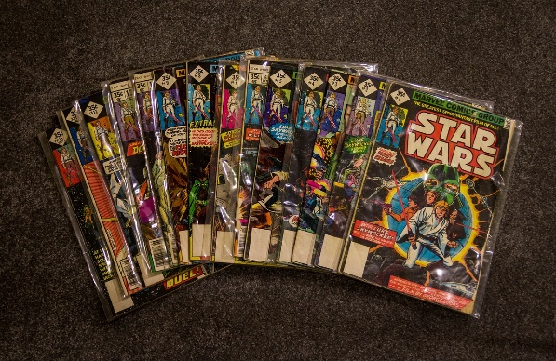

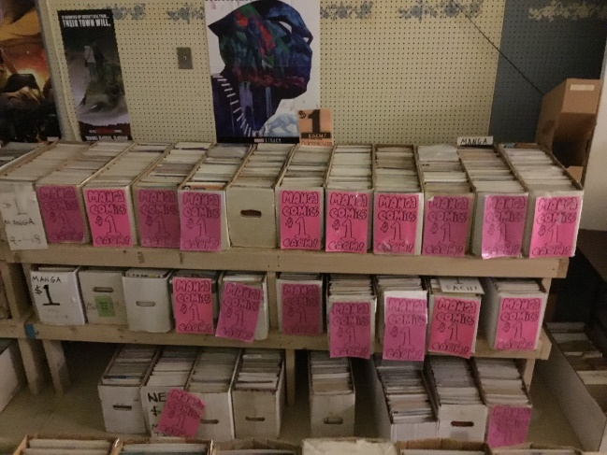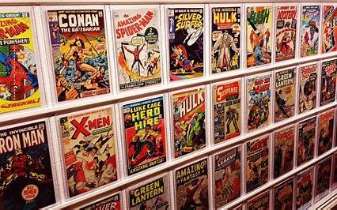

**Collection**

On this page I would like to Display a collection of comics by displaying the picture of a comic, the name, details, and price directly below the picture. The main content will be 2 columns of these sections that continue down the page. This allows you to look through your collection and complete our site goal of showing off the comics and searching through your collection. I can link my eBay again and show my store front at the bottom while keeping the header and footer the same.

**Featured**

I would like this page to display my favorite characters from marvel, DC, and independent artists. This would include the group then the character, a picture of the character, details about the character and a comic book that I have of the character. This would be in a similar profile to the collection page but this would have the marvel bolded then the character bellow that which would be slightly smaller, with the paragraph bellow. The image of the comic would be next to the bolded heading.